**ASSIGNMENT 1 FRONT SHEET**

|  |  |  |  |
| --- | --- | --- | --- |
| **Qualification** | **BTEC Level 5 HND Diploma in Computing** | | |
| **Unit number and title** | 10: Website Design & Development | | |
| **Submission date** |  | **Date Received 1st submission** |  |
| **Re-submission Date** |  | **Date Received 2nd submission** |  |
| **Student Name** | Bùi Hương Linh | **Student ID** | GBH200662 |
| **Class** | GCH1002 | **Assessor name** | Lại Mạnh Dũng |
| **Student declaration**  I certify that the assignment submission is entirely my own work and I fully understand the consequences of plagiarism. I understand that making a false declaration is a form of malpractice. | | | |
|  |  | **Student’s signature** |  |

**Grading grid**

|  |  |  |  |  |  |  |  |
| --- | --- | --- | --- | --- | --- | --- | --- |
| P1 | P2 | P3 | P4 | M1 | M2 | M3 | D1 |
|  |  |  |  |  |  |  |  |

|  |  |  |
| --- | --- | --- |
| **❒ Summative Feedback: ❒ Resubmission Feedback:** | | |
| **Grade:** | **Assessor Signature:** | **Date:** |
| **Signature & Date:** | | |

Task 1: PowerPoint Structure

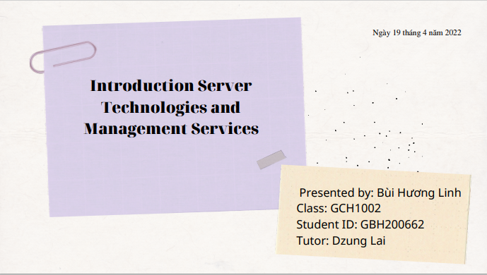

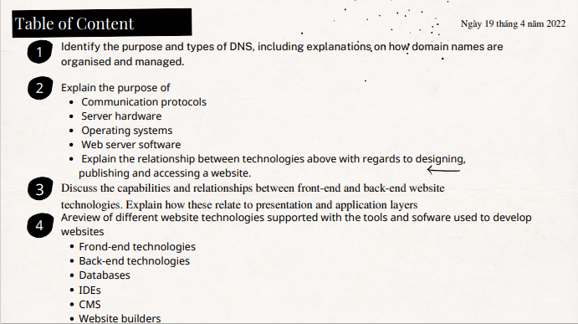

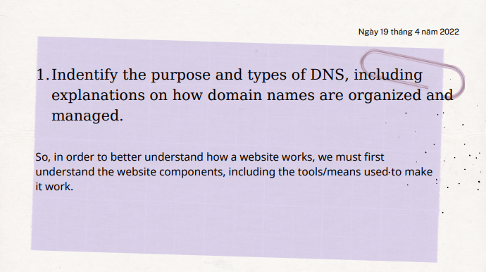

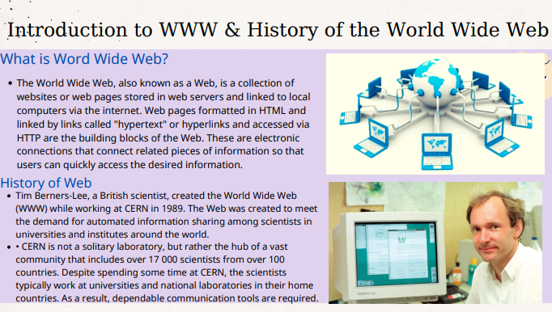

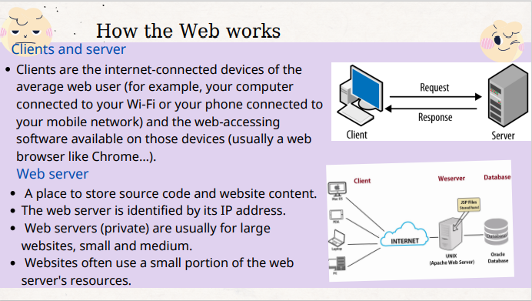

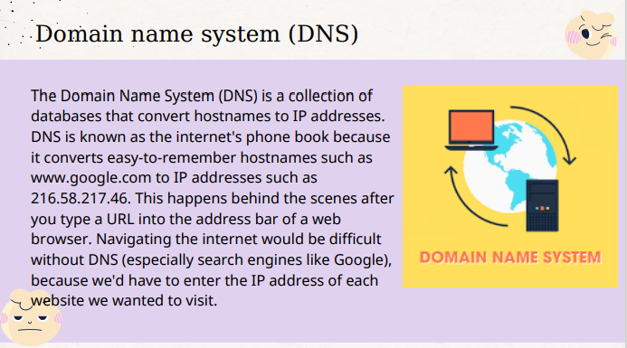

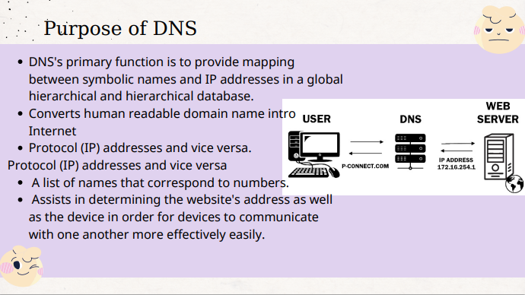

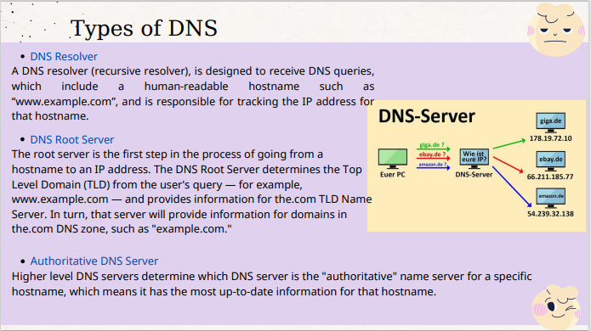

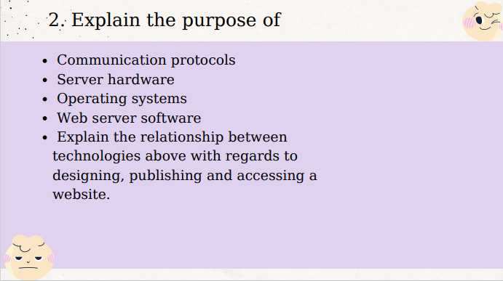

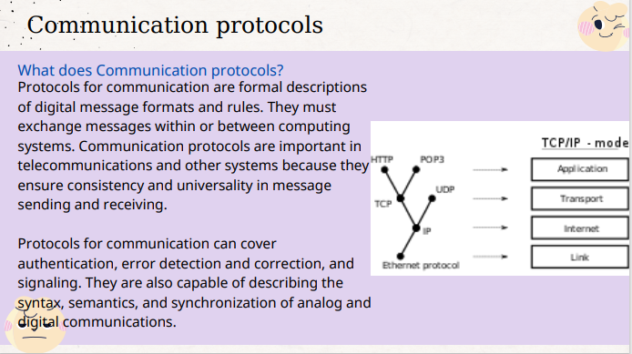

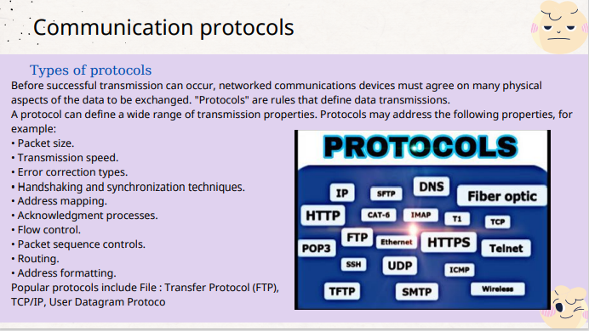

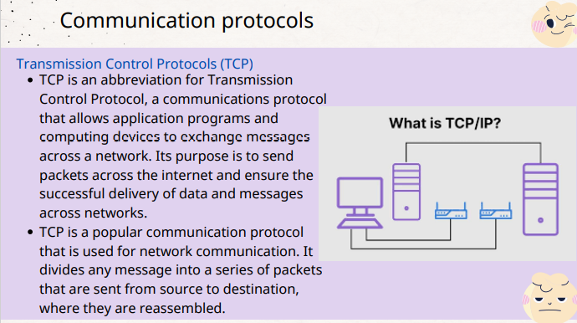

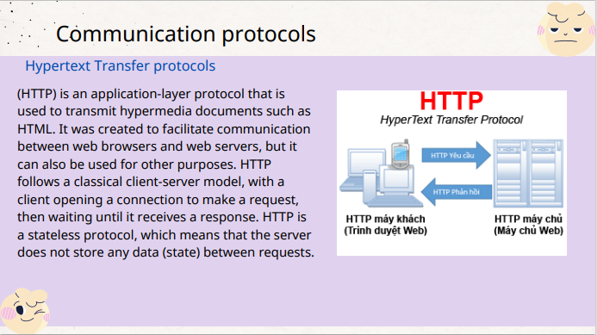

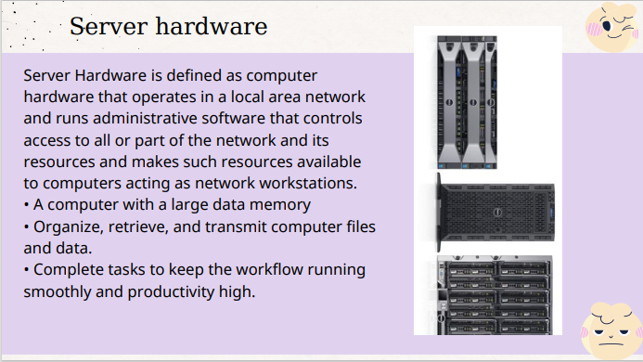

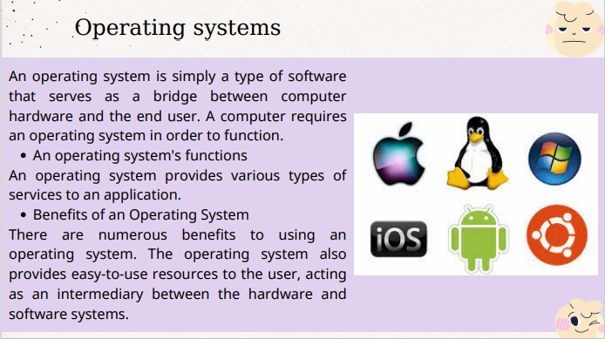

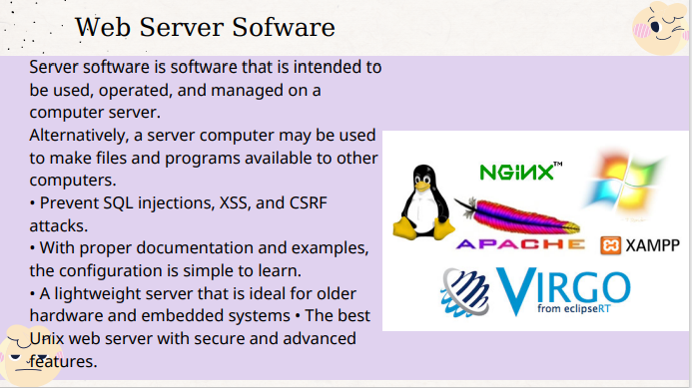

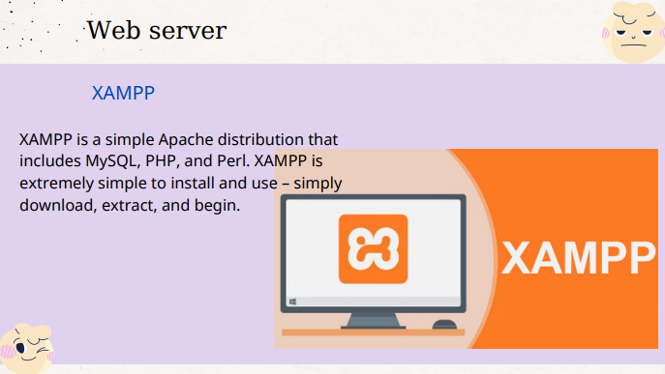

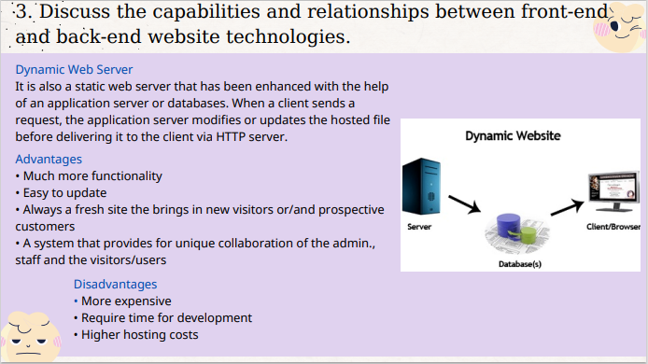

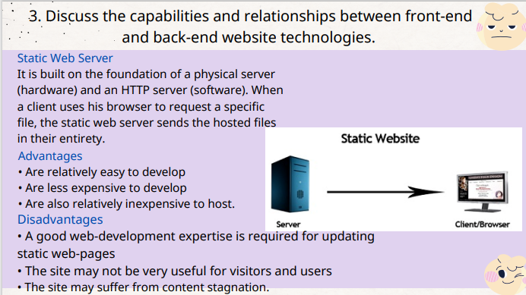

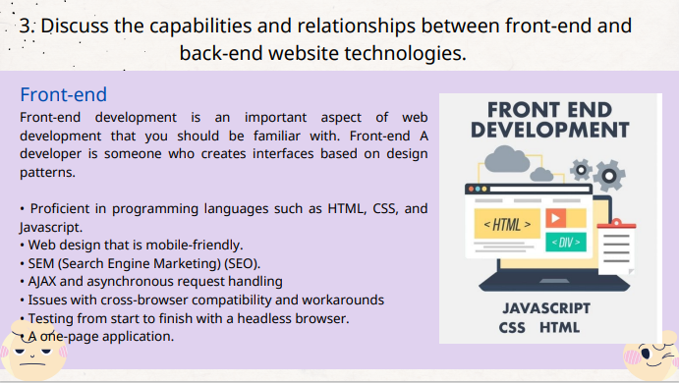

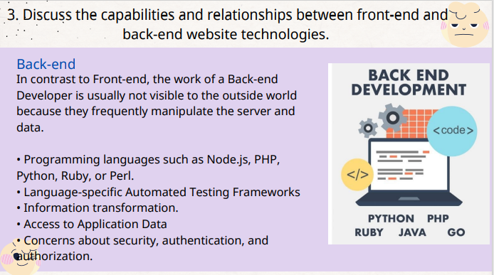

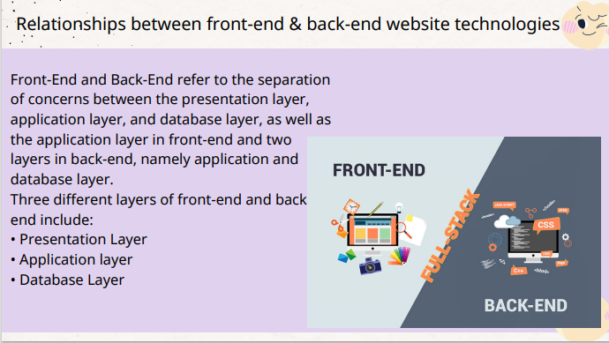

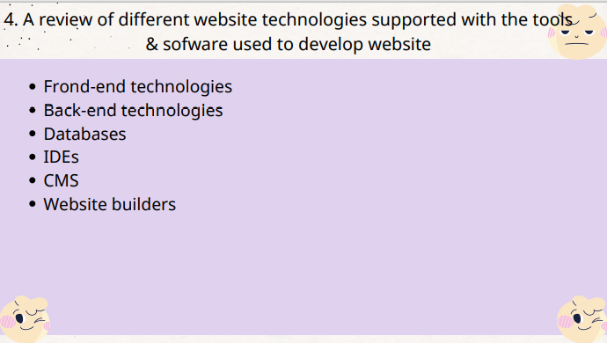

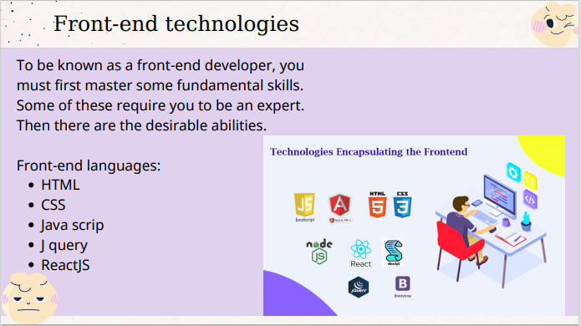

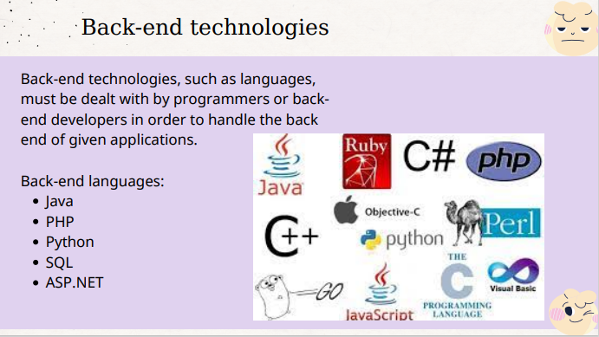

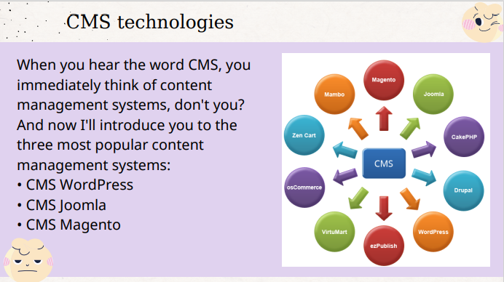

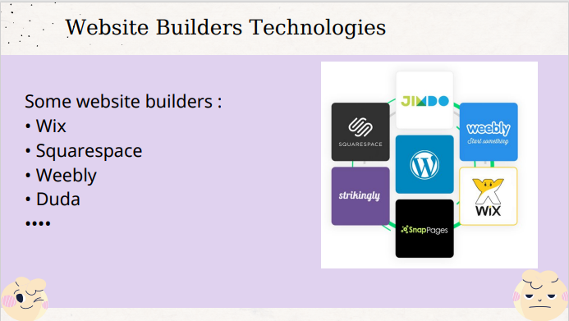

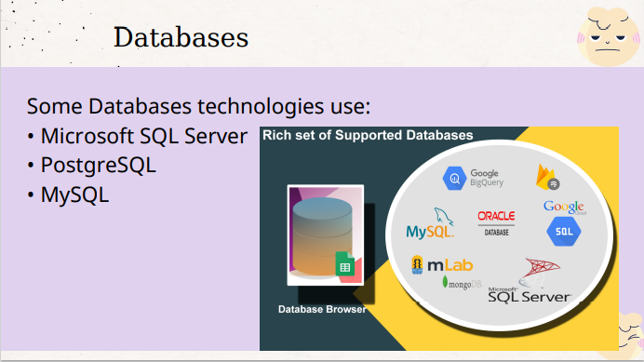

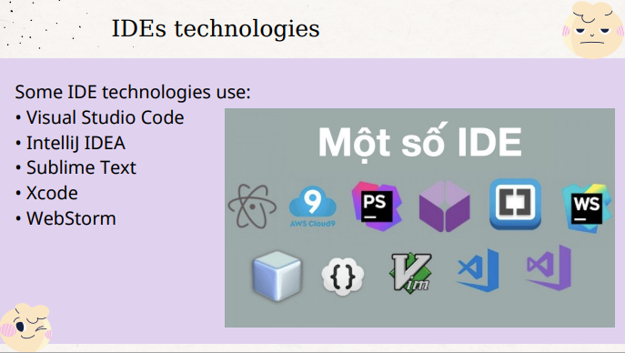

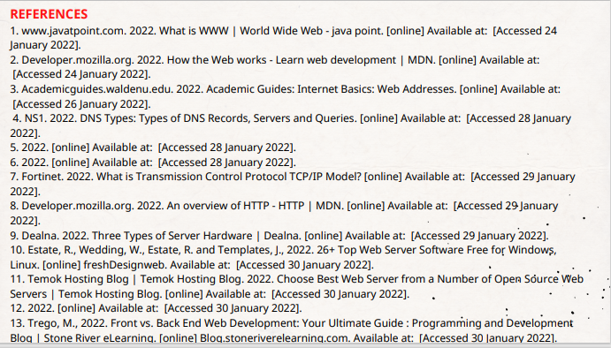

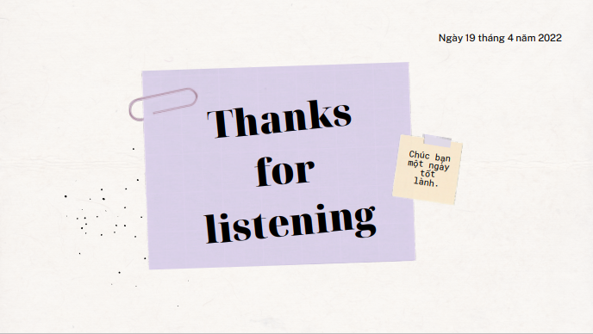

Task 2: Guidebook/Report

1. Identify the purpose and types of DNS, including explanations on how domain names are orgainises and managed (P1)
2. History of Website

Tim Berners-Lee, a computer scientist, invented the World Wide Web in 1989 in a laboratory in Geneva, Switzerland. (Javatpoint, 2021) He devised a method for navigating between files that makes use of:

* + Hyper link Framework (HTTP).
  + Hyper Text Markup Language (HTML).
  + Web browser and web server.

1. How does the Website work

Clients are the internet-connected devices of the average web user (for example, your computer connected to your Wi-Fi or your phone connected to your mobile network) and the web-accessing software available on those devices (usually a web browser like Chrome...). (Developer, 2022)

1. Web server

* A place to store source code and website content.
* The web server is identified by its IP address.
* Web servers (private) are usually for large websites, small and medium.
* Websites often use a small portion of the web server's resources.

1. Domain name system(DNS)

The Domain Name System (DNS) is a collection of databases that convert hostnames to IP addresses. DNS is known as the internet's phone book because it converts easy-to-remember hostnames such as www.google.com to IP addresses such as 216.58.217.46. This happens behind the scenes after you type a URL into the address bar of a web browser. Navigating the internet would be difficult without DNS (especially search engines like Google), because we'd have to enter the IP address of each website we wanted to visit. (Networkstraining, 2022)

1. The purpose of DNS

* DNS's primary function is to provide mapping between symbolic names and IP addresses in a global hierarchical and hierarchical database.
* Converts human readable domain name intro Internet
* Protocol (IP) addresses and vice versa.
* Protocol (IP) addresses and vice versa
* A list of names that correspond to numbers.
* Assists in determining the website's address as well as the device in order for devices to communicate with one another more effectively easily.

(Ns1, 2022)

1. Types of DNS

In total, about 3 types of servers participate in the domain name resolution system:

* DNS Recursive resolvers: A DNS resolver (recursive resolver), is designed to receive DNS queries, which include a human-readable hostname such as “www.example.com”, and is responsible for tracking the IP address for that hostname.
* DNS Root Server: The root server is the first step in the process of going from a hostname to an IP address. The DNS Root Server determines the Top Level Domain (TLD) from the user's query — for example, www.example.com — and provides information for the.com TLD Name Server. In turn, that server will provide information for domains in the.com DNS zone, such as "example.com."
* Authoritative Name server: Higher level DNS servers determine which DNS server is the "authoritative" name server for a specific hostname, which means it has the most up-to-date information for that hostname.

(Cloudflare, 2022)

1. Explain the purpose of (P2)
2. Communication protocols

Communication protocols are formal descriptions of digital message formats and rules. They are required to exchange messages in or between computing systems. There are several protocols used to communicate or convey information on the Internet:

* TCP/IP: Transmission Control Protocol and Internet Protocol are communication protocols that specify how data should be transmitted across the internet. TCP facilitates the connection of client devices to servers based on their IP addresses.
* DNS: Domain Name System converts website domain names into numeric IP addresses on the server.
* HTTP: Hyper Text Transfer Protocol is an application protocol that defines the language that client devices and servers use to communicate with one another.

(Fortinet, 2022), (Developer, 2022)

1. Server hardware

Server Hardware is defined as computer hardware that operates in a local area network and runs administrative software that controls access to all or part of the network and its resources and makes such resources available to computers acting as network workstations.

* A computer with a large data memory
* Organize, retrieve, and transmit computer files and data.
* Complete tasks to keep the workflow running smoothly and productivity high.

(Dealna, 2022)

1. Operating systems

An operating system is simply a type of software that serves as a bridge between computer hardware and the end user. A computer requires an operating system in order to function.

* An operating system's functions: An operating system provides various types of services to an application.
* Benefits of an Operating System: There are numerous benefits to using an operating system. The operating system also provides easy-to-use resources to the user, acting as an intermediary between the hardware and software systems.

(Max, 2020)

1. Web server software

Server software is software that is intended to be used, operated, and managed on a computer server. Alternatively, a server computer may be used to make files and programs available to other computers.

* Prevent SQL injections, XSS, and CSRF attacks.
* With proper documentation and examples, the configuration is simple to learn.
* A lightweight server that is ideal for older hardware and embedded systems • The best Unix web server with secure and advanced features.

(Bill, 2021)

1. Discuss the capabilities and relationships between front-end and back-end website technologies. (P3)
2. What is front-end

Front-end development is an important aspect of web development that you should be familiar with. Front-end A developer is someone who creates interfaces based on design patterns.

* Proficient in programming languages such as HTML, CSS, and Java script.
* Web design that is mobile-friendly.
* SEM (Search Engine Marketing) (SEO).
* AJAX and asynchronous request handling.
* Issues with cross-browser compatibility and workarounds.
* Testing from start to finish with a headless browser.
* A one-page application.

1. What is back-end

In contrast to Front-end, the work of a Back-end Developer is usually not visible to the outside world because they frequently manipulate the server and data.

* Programming languages such as Node.js, PHP, Python, Ruby, or Perl.
* Language-specific Automated Testing Frameworks
* Concerns about security, authentication, and authorization.
* Information transformation.
* Access to Application Data

1. Relationships between front-end & back-end website technologies

Front-End and Back-End refer to the separation of concerns between the presentation layer, application layer, and database layer, as well as the application layer in front-end and two layers in back-end, namely application and database layer.

Three different layers of front-end and back end include:

* Presentation Layer
* Application layer
* Database Layer

(Trego, 2016)

1. A review of different website technologies supported with the tools and sofware used to develop websites (P4)
2. Frond-end technologies

To be known as a front-end developer, you must first master some fundamental skills. Some of these require you to be an expert. Then there are the desirable abilities.

Front-end languages:

* HTML
* CSS
* Java scrip
* J query
* ReactJS

1. Back-end technologies

Back-end technologies, such as languages, must be dealt with by programmers or back-end developers in order to handle the back end of given applications.

Back-end languages:

* Java
* PHP
* Python
* SQL
* ASP.NET

1. Databases

Database technologies store, organize, and process information in a way that allows users to easily and intuitively go back and find details they are looking for. Database technologies come in a variety of sizes and shapes, ranging from complex to simple, large to small.

* MySQL
* Microsoft SQL Server
* PostgreSQL

..................

1. IDEs technologies

Web development IDEs are powerful tools with numerous features such as autocomplete, syntax checking, debugger, providing a suggestion, viewing a live web page inside the IDE for a better understanding of the output, and so on.

Some IDE technologies use:

* Visual Studio Code
* Sublime Text
* X code
* Web Storm

1. CMS technologies

When you hear the word CMS, you immediately think of content management systems, don't you? And now I'll introduce you to the three most popular content management systems:

* CMS WordPress
* CMS Joomla
* CMS Magento

..............

1. Website builders

A Website Builder is a software or a set of tools, developed by IT professionals with the aim to help people who do not know how to code, design or build their own websites.

* Wix
* Squarespace
* Weebly
* Duda

..............

(springwk_wp, 2015), (Trego, 2016)

# Bibliography

Bill, G. (2021, December 6). *26+ Top Web Server Software Free for Windows, Linux*. Retrieved from freshdesignweb.com: https://freshdesignweb.com/web-server-software-free/

Cloudflare. (2022). *DNS server types*. Retrieved from cloudflare.com: https://www.cloudflare.com/learning/dns/dns-server-types/#:~:text=What%20are%20the%20different%20types,TLD%20nameservers%2C%20and%20authoritative%20nameserve

Dealna. (2022). *Three Types of Server Hardware*. Retrieved from dealna.com: https://dealna.com/en/Article/Post/1391/Three-Types-of-Server-Hardware

Developer. (2022). *An overview of HTTP*. Retrieved from developer.mozilla.org: https://developer.mozilla.org/en-US/docs/Web/HTTP/Overview

Developer. (2022). *How the Web works*. Retrieved from developer.mozilla.org: https://developer.mozilla.org/en-US/docs/Learn/Getting_started_with_the_web/How_the_Web_works#clients_and_servers

Fortinet. (2022). *What is a Transmission Control Protocol TCP/IP Model?* Retrieved from fortinet.com: https://www.fortinet.com/resources/cyberglossary/tcp-ip

Javatpoint. (2021). *What is World Wide Web?* Retrieved from javatpoint.com: https://www.javatpoint.com/what-is-world-wide-web

Max, D. (2020, March 6). *Choose Best Web Server from a Number of Open Source Web Servers*. Retrieved from temok.com: https://www.temok.com/blog/choose-best-web-server-from-a-number-of-open-source-web-servers/

Networkstraining. (2022). *DNS Port Number – What is Domain Name System – How DNS Works*. Retrieved from networkstraining.com: https://www.networkstraining.com/what-is-dns/

Ns1. (2022). *DNS: Types of DNS Records, DNS Servers and DNS Query Types*. Retrieved from ns1.com: https://ns1.com/resources/dns-types-records-servers-and-queries

springwk_wp. (2015, November 24). *The Various Differences Between The Static And The Dynamic Web Pages And Websites*. Retrieved from springworks.biz: https://www.springworks.biz/2015/11/24/static-and-dynamic-website/

Trego, M. (2016, November 23). *Front-end & Back-end Web Development: Your Ultimate Guide*. Retrieved from blog.stoneriverelearning.com: https://blog.stoneriverelearning.com/front-vs-back-end-web-development-your-ultimate-guide/